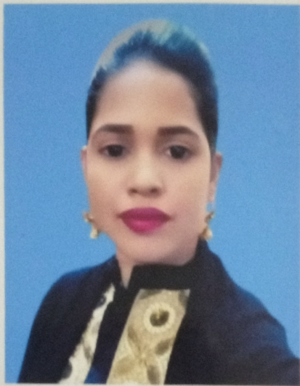

Resume Of Shakila Akter
144/1 Matikata,Dhaka Cantt,
Dhaka-1206, Bangladesh.
Mobile No : 01961030870
Email: Shakila_Mini@Yahoo.Com

I would like to improve my skills by using my talents and qualifications and simultaneously to be a part of the development and progress of the organization like airlines and always try to consider about its fame and reputation.

ACADEMIC QULIFICATION :

- Masters (Degree)

Degree : Masters of Business Studies (MBS).
Institution : Govt. Titumir College. [National University]
Result (CGPA) : 2nd Division, 2013

- BACHELOR (Degree Pass)

Degree : Bachelor of Business Studies (BBS).
Institution : Govt. Titumir College. [National University]
Result (CGPA) : 2nd Division, 2011

- HIGHER SECONDARY CIRTIFICATE

Degree : Higher Secondary Certificate (H.S.C)
Institution : Shaheed Ramijuddin College
Result (CGPA) : 3.80 (Scale 5), 2006
Group : Business Studies

- SCHOOL SECONDARY CERTIFICATE (SSC)

Degree : School Secondary Certificate (S.S.C)
Institution : Rajargoan High School, Chandpur.
Result (CGPA) : 3.31 (Scale 5), 2004
Group : Business Studies

EXPERIENCE

- Worked at Muna Travels & Tours Ltd. as an Ticketing Reservation & Sales.

Period : 1st July 2019- Oct 2019

- Worked at Configure Holding Limited as an Accounts and HR.

Period : 1st June 2017 – June 2019

- Worked at Customer service agent at AIRTEL BANGLADESH LTD.

Period : 1st May, 2014-31 May 2016

- Worked at Expedient Care as an Executive-Documentation and Patient Support.
Period : 1st Jan 2011 -31 Dec 2013

PERSONAL DETAILS

Father's Name : Md. Monir Hossain
Mother's Name : Shefali Begum
Date of Birth : 1st January 1989
Height : 5'- 4''
Marital Status : married
Permanent Address : Vill- Rajargaon, PO-Rajargaon,
PS- Hajiganj, Dist.- Chandpur.
Religion : Islam
Blood Group : B+ ‘ve'
Nationality : Bangladeshi.

HONOUR & AWARD

- First prize of the Essay Competition at Intraschool. Held In Chandpur In 2002.

SKILLS

- Computer: Good working knowledge of Microsoft Word, Excel, E-Mail, Internet, Software Installation.

- Language: Bengali & English, fluent written and oral level.

- Organisational: Time management skills gained through projects and course work and prioritising tasks to meet deadlines.

- Communication and Interpersonal: Excellent team working skills gained through coursework, job experiment and extracurricular activities.

TRAINING

- Training on Flight Cabin Crew: Have successfully completed a course of BASIC FLIGHT CABIN CREW with the jobsA1.com from 20th September'2013 to 23rd November'2013.

INTERESTS

Travelling, listening music, Reading story books, like to decorate room, Cricket.


Shakila Akter

REFERENCES

1. Md. Nasir Uddin
Director,
Winsoft BD Pvt. Ltd
661 (5th floor), West Shewrapara, Mirpur, Dhaka
Mobile No- 01916080407

2. Giashuddin Mahmood
Ex Country Manager
United Airways BD Ltd.
Mobile 01797188188

